**MIDDLE EAST TECHNICAL UNIVERSITY**

**DEPARTMENT OF ELECTRICAL AND ELECTRONICS ENGINEERING**

**PROCESS CONTROL LABORATORY**

**EXPERIMENT : PHYSIOLOGICAL HEART-RATE CONTROL SUB-SYSTEM MODELING/IDENTIFICATION**

1.Objective

The objective of this experiment is to record and obtain an approximate model (e.g. an FOPDT model) of how your heart rate changes with changing physical activity. Furthermore, students will get familiar with sub-system modeling and system identification concept.

2. Information

*System Identification Method*

System identification is a method to obtain mathematical model of dynamic systems. It is useful to predict the behavior of the system and it provides us the opportunity to calculate or control the desired behavior. System identification method brings with parameter estimation. There are three basic steps of applying system identification method to a dynamic system:

* collecting useful data,
* choosing an appropriate model,
* parameter estimation.

To give you a better understanding of system identification steps, block diagram of identification loop is provided in Figure 1.

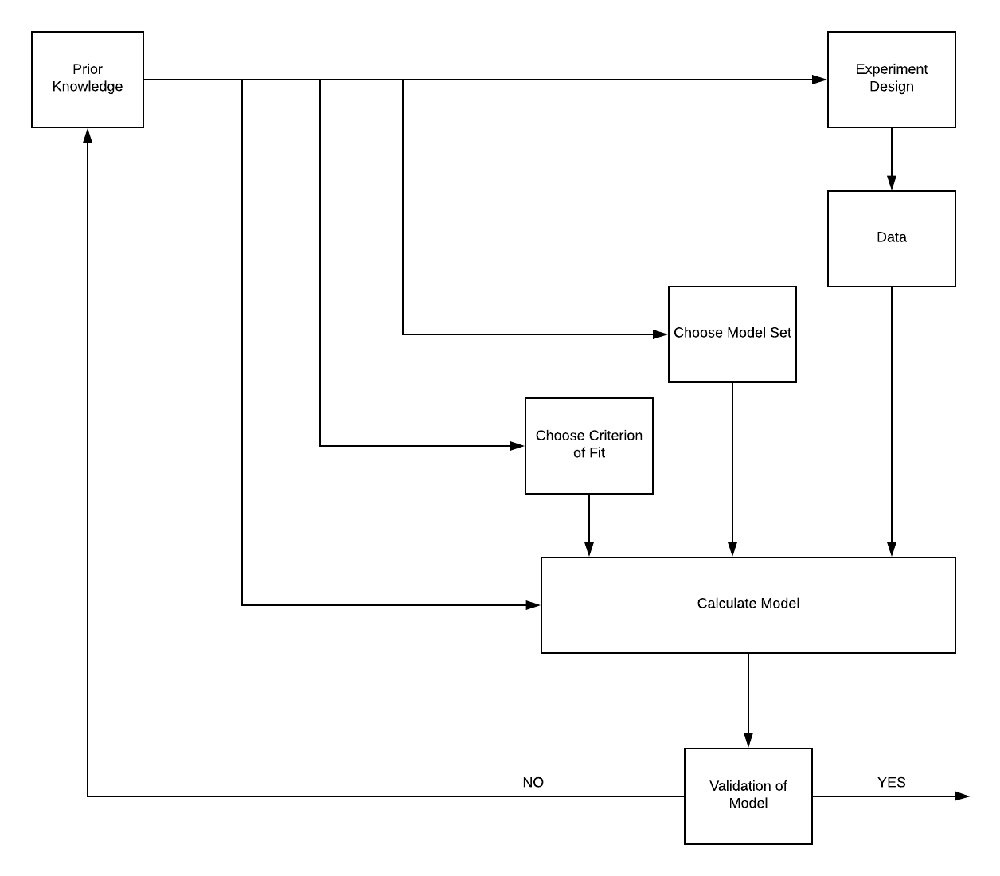

Figure 1: Block diagram of system identification loop

In this experiment, you are going to use system identification method to model a person’s heart rate under the effects of different conditions. Obviously, it is not possible to obtain a precise and linear model of heart rate response if you consider the complexity of human body. For instance, when a runner doubles its speed, his or her heart rate will not be doubled.

*Hemodynamic System*

Hemodynamic system is responsible of supplying oxygen and nutrients to every single cell in body and carries away carbon dioxide and metabolic wastes from them. In this circulation the heart acts as a pump producing a pressure between arterial and venous circulation. Driven by this pressure, deoxygenated blood from the venous circulation flows back to the right heart where it is pumped through the lung. In the lung the blood is enriched with oxygen and re-enters systemic circulation when pumped into the aorta by the left ventricle. The arterial tree then supplies the whole body with oxygen and nutrients. From the peripheral regions, where the oxygen and the nutrients are used, the blood returns to the right heart and the circulation is closed [1]. In order for you to understand the basics of human circulatory system, hemodynamic system is represented in Figure 2.

The necessity of oxygen changes under different physical and emotional conditions. Therefore, to respond to different amount of oxygen demands, heart rate changes accordingly. You carry out an experiment of a runner’s heart rate in different circumstances. Although it is not a linear system, you can still determine a few operating points, obtain different models and develop your controllers. However, notice that due to non-linearity of hemodynamic system, it would be more accurate to obtain multiple operating points.

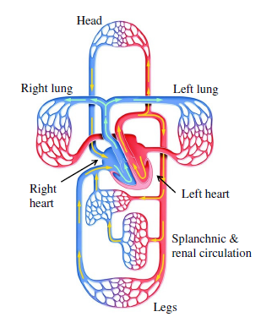

Figure 2: Representation of human hemodynamic system (Retrieved from [www.research-collection.ethz.ch](http://www.research-collection.ethz.ch))

**Polar FT-7 Heart Rate Transmitter/Monitor**

The heart rate transmitter used in this experiment is Polar FT-7. The product consists of 3 parts:

* Chest Strap: Basically an interface between the body and the transmitter.
* Heart Rate Transmitter: Wireless heart rate sender
* Hear Rate Monitor Watch: Receives the heart rate data and prints it on its screen

**Polar Treadmill (Model bilinmiyor)**

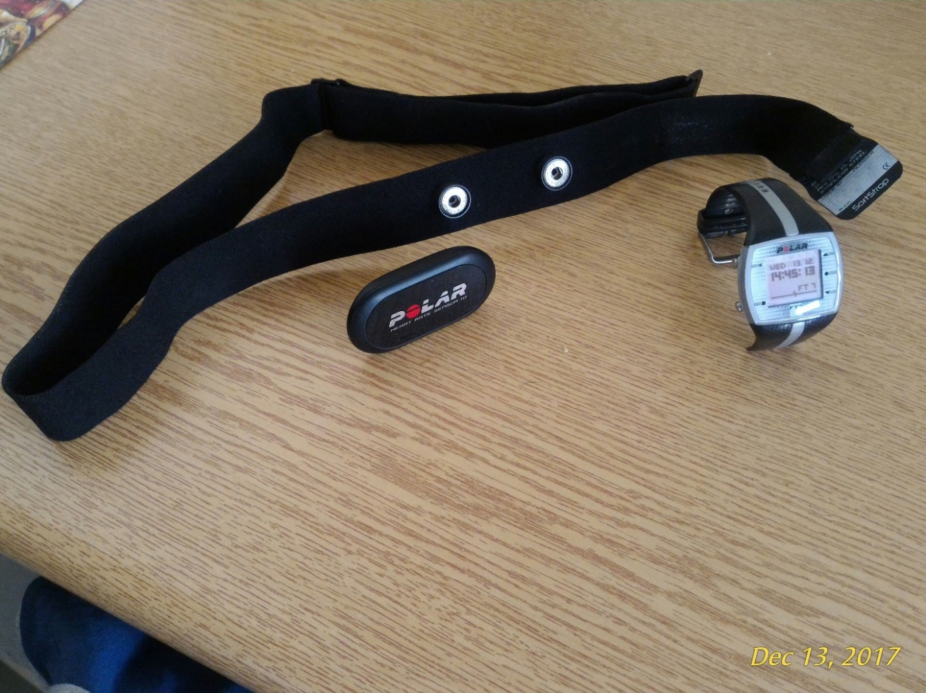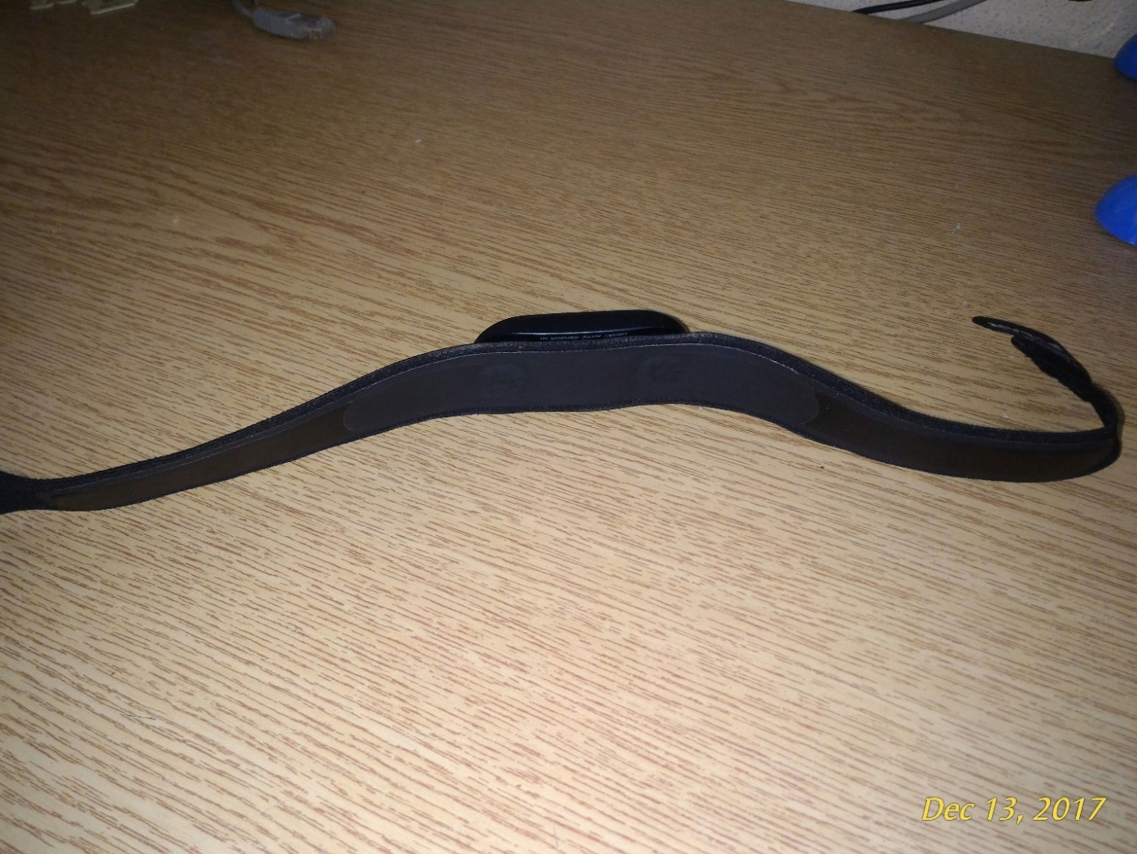

Chest Strap

HR Monitor Watch

The Strap’s Body/Device Interface

HR Transmitter

**Life Fitness 9500 HR Treadmill**

The treadmill is used to control the running conditions (speed and track incline) precisely. It also displays the received heart rate information to its screen automatically, when the Polar FT-7 is used as HR transmitter. Also, the treadmill has a number keyboard so that the desired speed can be directly given as input to it. The METU Sport Center has 6 of these treadmills and they are free to use to the students.

